

DEPARTMENT OF ADSE

CSE434P-Computer Networks
PROJECT REPORT

B. Tech - Computer Science and Engineering
(AIML)

Submitted By:
Abel Alexander - 2462004
Annmarie Vinish – 2462041
Darain Brit A – 2462060
4BTCSAIML A

Abstract
Natural disasters frequently damage conventional communication infrastructure, disrupting coordination between victims and rescue teams. This project presents a simulation of an Emergency Communication Network using a drone-based mesh architecture. The system is implemented in two layers:
- Cisco Packet Tracer simulation demonstrating dynamic routing and network redundancy using OSPF.
- Python-based distributed simulation implementing priority-based message transmission using priority queues.
The system ensures self-healing communication, multi-hop forwarding, and prioritization of life-critical emergency messages. This project integrates networking principles and distributed systems concepts to model disaster-resilient communication.

Background
During disasters, communication systems such as cellular towers may fail. Drone-based networks provide temporary communication infrastructure where mobile nodes form a mesh network to relay emergency messages. This project simulates such a system at:
- Network Layer (Cisco Packet Tracer)
- Application Layer (Python Distributed System)
Problem Statement
The project addresses:
- Maintaining communication when infrastructure fails.
- Dynamically rerouting traffic if a node fails.
- Prioritizing emergency messages.
- Simulating distributed multi-hop communication.
Objectives
- Design a drone mesh topology.
- Implement OSPF dynamic routing.
- Add redundant backup links.
- Simulate priority-based message transmission.
- Demonstrate self-healing network behaviour.

Cisco Packet Tracer Implementation
Network Topology
The drone nodes are represented by routers connected in a mesh topology with a backup link.
Topology:
PC → R1 → R2 → R3 → R4 → Server
Backup Link: R1 ↔ R3
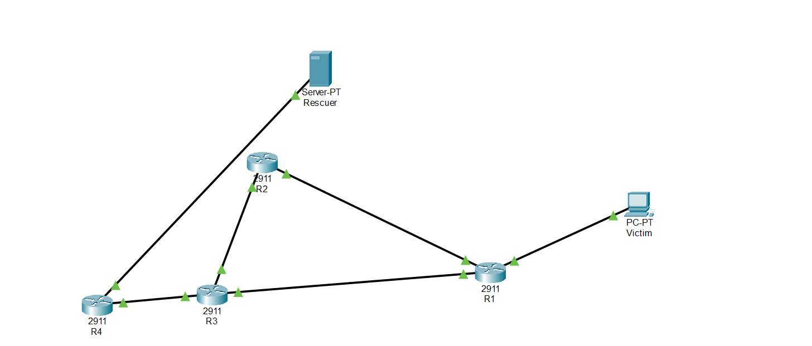

IP Addressing and OSPF Configuration
Each router interface is assigned a unique subnet. OSPF routing protocol is enabled on all routers to allow automatic path discovery and rerouting.

Dynamic Routing and Self-Healing
When Router R2 is shut down, OSPF recalculates the shortest path and reroutes traffic via the backup link.This demonstrates:
- Fault tolerance
- Redundancy
- Self-healing communication
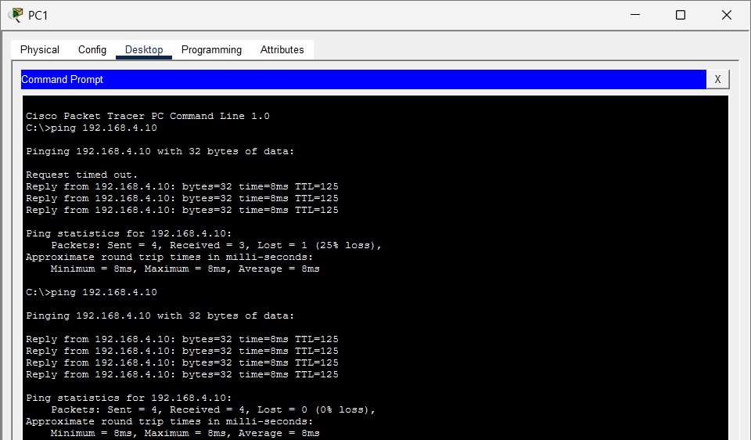
Quality of Service (QoS)
QoS policies were configured using:
- Access Control Lists (ACL)
- Class Maps
- Policy Maps
- Service Policies
Traffic classes:
- HIGH – Medical emergency
- MEDIUM – Urgent assistance
- LOW – Default traffic
Due to limitations of Cisco Packet Tracer, full real-time queue scheduling under congestion cannot be visually demonstrated.

Python Distributed Mesh Simulation
System Architecture
The Python-based system consists of:
- sender_client.py – Victim device simulator
- node.py – Drone mesh node
- base_station.py – Rescue control center
Messages are forwarded dynamically between nodes until reaching the base station.
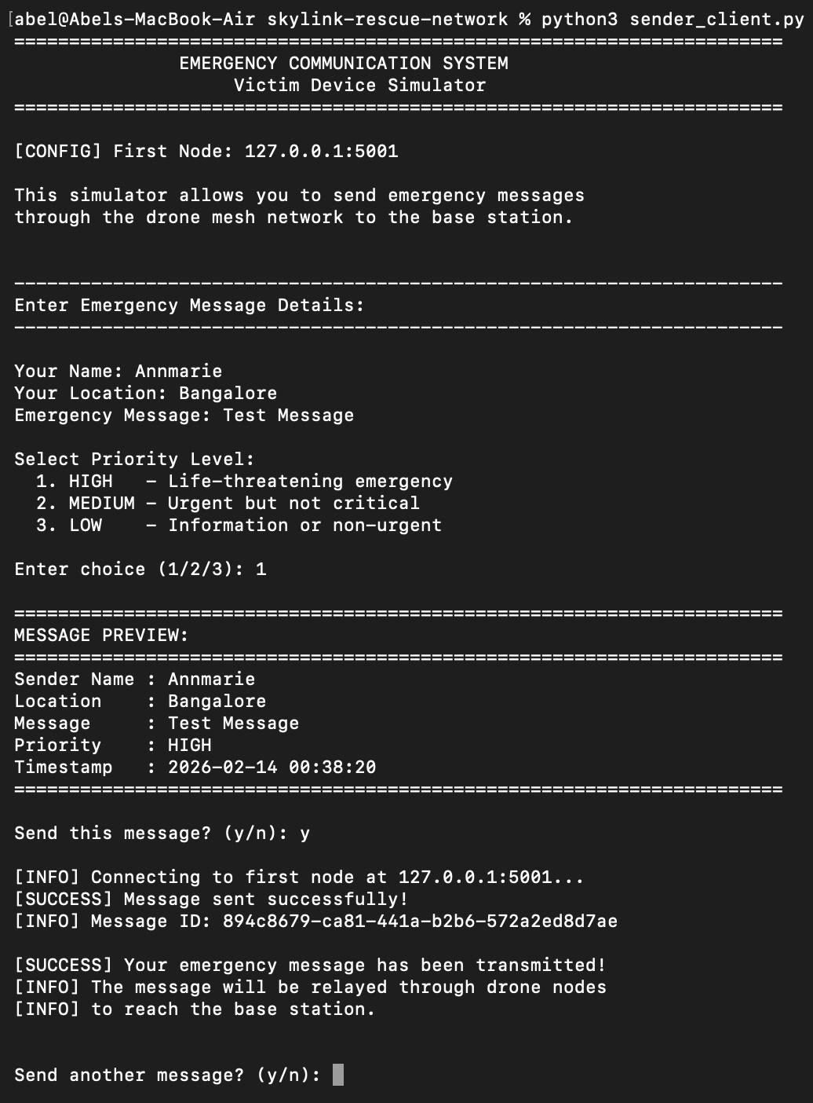

Priority Queue Implementation
Each drone node maintains a priority queue:
- HIGH → Priority value 1
- MEDIUM → Priority value 2
- LOW → Priority value 3
Messages are processed based on priority before forwarding.
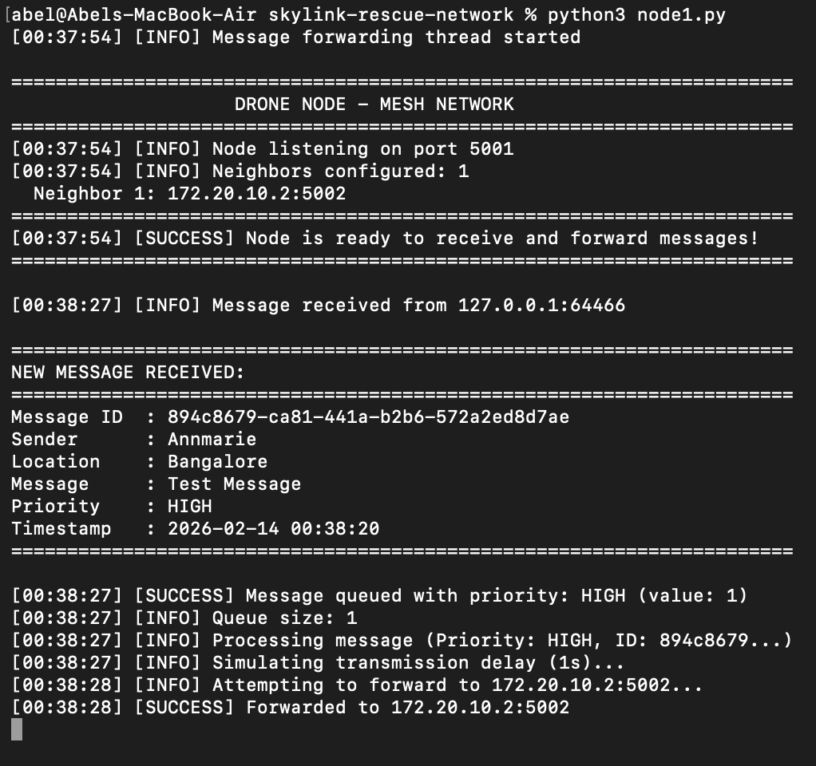

Dynamic Forwarding
Each node maintains a neighbour list and attempts to forward messages to the next available node. If a node fails, alternate forwarding can occur.
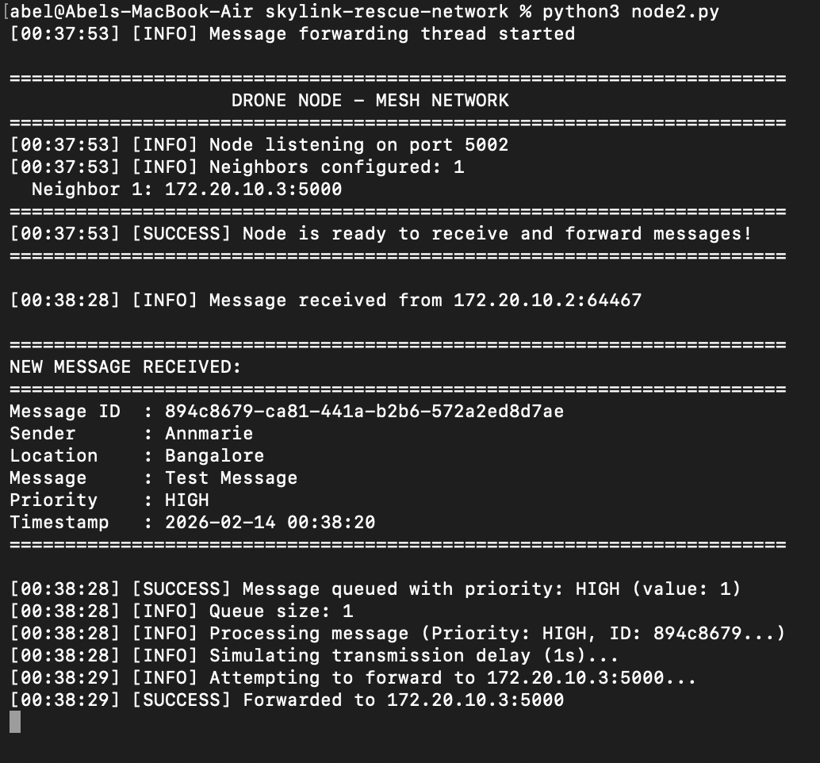

Base Station Processing
The base station:
- Receives messages
- Displays structured output
- Stores data in messages.json
- Tracks priority statistics
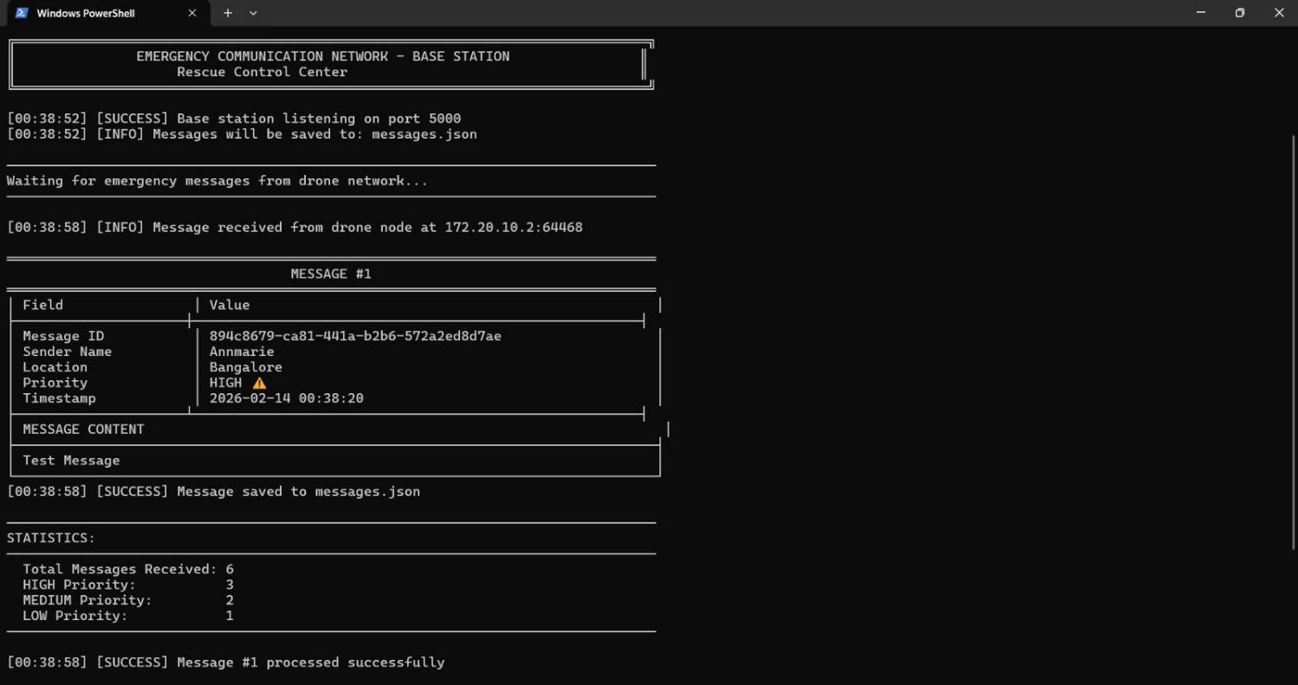
Results
The system successfully demonstrated:
- Multi-hop communication
- Dynamic routing with automatic rerouting
- Redundant backup path activation
- Priority-based message processing
- Successful end-to-end transmission
Cisco Packet Tracer validated routing and redundancy behavior.
Python simulation validated priority scheduling and distributed forwarding logic.

Conclusion
The project successfully models a drone-based emergency communication network at both networking and application layers.
Key achievements:
- Dynamic OSPF routing
- Redundant topology design
- Priority-based emergency transmission
- Self-healing network behavior
- Distributed system simulation
The integration of Cisco routing concepts and Python distributed systems creates a comprehensive disaster-resilient communication model.
Future Scope
- Real wireless mesh implementation
- Cloud-based monitoring dashboard
- AI-based route optimization
- Integration with IoT distress sensors
- SDN-based centralized control
- Real drone hardware deployment

